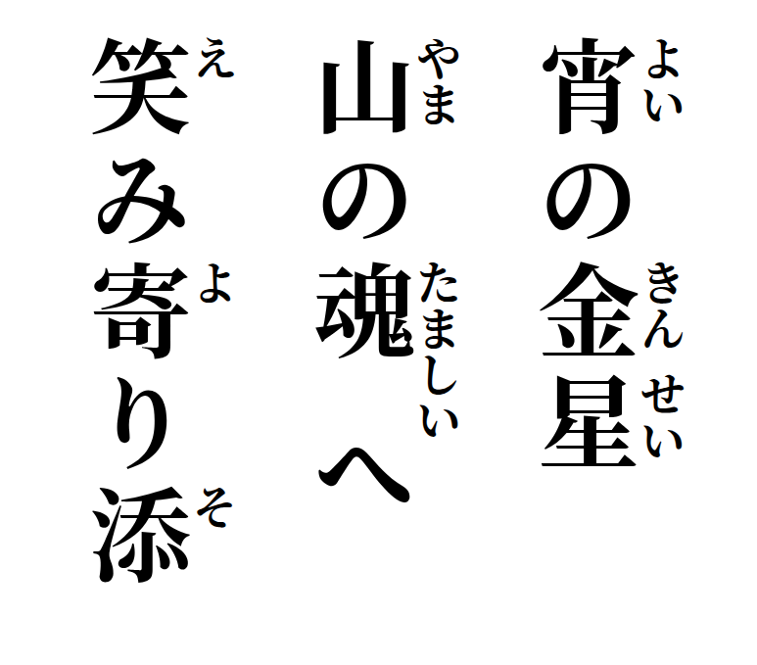
Evening Venus
toward the mountain's soul—
smiles draw close.

